**LOOP AND CONDITIONAL OPERATORS**

**LAB # 07**



**Fall 2021**

**CSE304L Computer Organization & Architecture**

Submitted by: **Ashfaq Ahmad**

Registration No: **19PWCSE1795**

Class Section: **B**

Student Signature: ______________

Submitted to:

**Prof: Ammad khalil**

January 25, 2021

**Department of Computer Systems Engineering**

**University of Engineering and Technology, Peshawar**

**Task 01:**

Write a MIPS program to find factorial of input number.

**Source Code:**

.data

str: .asciiz"Name: Ashfaq Ahmad\nReg No: 19pwcse1795"

str1: .asciiz"\nPlease Enter a Number:"

str2: .asciiz"The Factorial of input Number is:"

.text

main:

li $v0,4

la $a0,str

syscall

again:

li $v0,4

la $a0,str1

syscall

li $v0,5

syscall

move $t0,$v0

beq $t0,$0 abc #this condition for zero input.

j exit1

abc:

addi $t0,1 #we will add 1 with zero. it will give 1 factorial.

exit1:

li $t2,1

add $t3,$t0,$0 #move input number to $t3.

li $v0,4

la $a0,str2

syscall

exit2:

sub $t0,$t0,$t2 #subtract 1 from input in each step.

bgt $t0,$t2 fact #subtract 1 from input until it reach to 1 itself.

j exit3 #condition false jump out from loop.

fact:

mul $t3,$t3,$t0 #multiply result of iteration stored in $t3 with decrement of $t0 in each iteration.

j exit2

exit3:

li $v0,1

move $a0,$t3

syscall

j again

li $v0,10

syscall

Output:

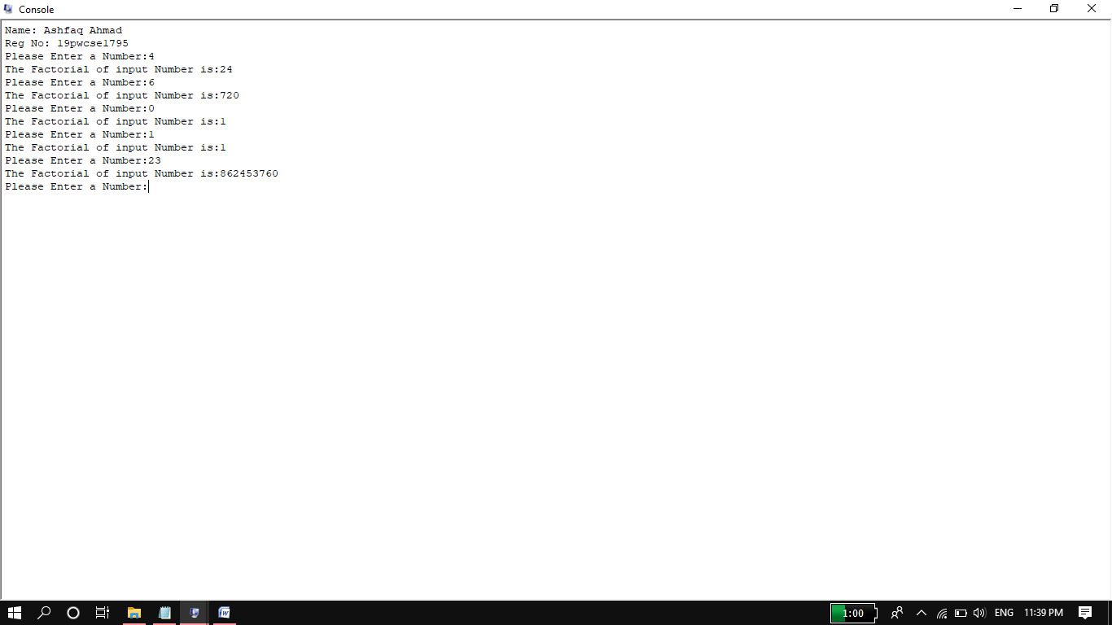

**Task 02:**

Write a program that print febuccani series of size n.

**Source Code:**

.data

str: .asciiz"Name: Ashfaq Ahmad\nReg No: 19pwcse1795"

str1: .asciiz"\nPlease Enter the size of febuccani Series:"

str2: .asciiz"The Series is:"

str3: .asciiz"\t"

.text

main:

li $v0,4

la $a0,str

syscall

li $v0,4

la $a0,str1

syscall

li $v0,5

syscall

move $t0,$v0

li $v0,4

la $a0,str2

syscall

li $t1,0

li $t2,1

li $t3,0

exit2:

bgt $t0,$t3 febuc

j exit1

febuc:

li $v0,1

move $a0,$t1

syscall

li $v0,4

la $a0,str3

syscall

add $t4,$t1,$t2

add $t1,$t2,$0

add $t2,$t4,$0

addi $t3,$t3,1

j exit2

exit1:

li $v0,10

syscall

**Output:**

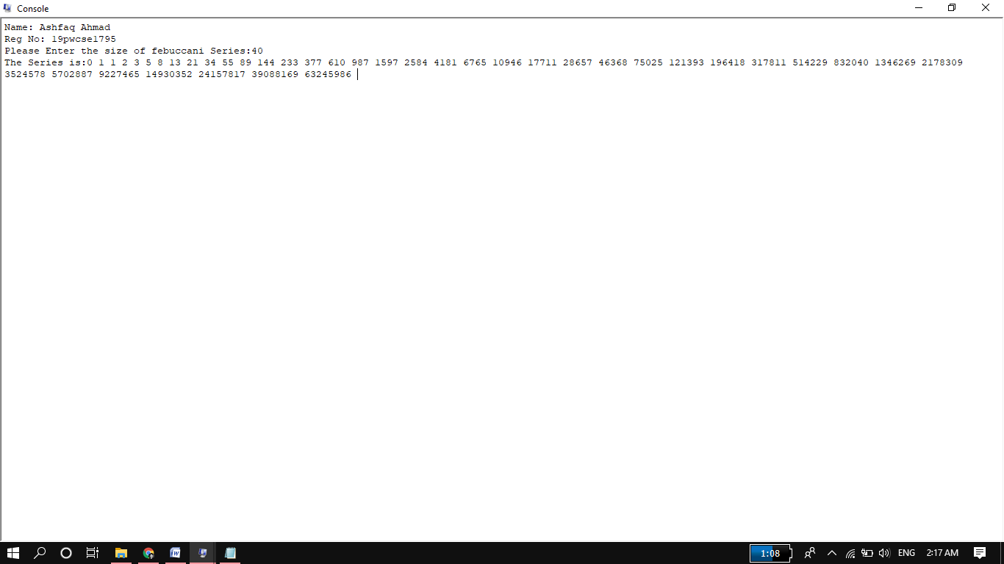

**Task 03:**

Write a MIPS program that prints all factors of input number.

**Source Code:**

.data

str: .asciiz "Name:Ashfaq Ahmad\nReg No:19pwcse1795\n"

str1: .asciiz "Please enter a number: "

str2: .asciiz "The Factors of input no is: "

str3: .asciiz " "

.text

main:

li $v0,4

la $a0,str

syscall

li $v0,4

la $a0,str1

syscall

li $v0,5

syscall

move $t0,$v0

li $v0,4

la $a0,str2

syscall

li $t1,1

exit3:

bgt $t0,$t1 check

j exit1

check:

div $t0,$t1

mfhi $t2

beq $t2,$0 factor

j exit2

factor:

li $v0,1

move $a0,$t1

syscall

li $v0,4

la $a0,str3

syscall

exit2:

addi $t1,$t1,1

j exit3

exit1:

li $v0,1

move $a0,$t0

syscall

li $v0,10

syscall

**Output:**

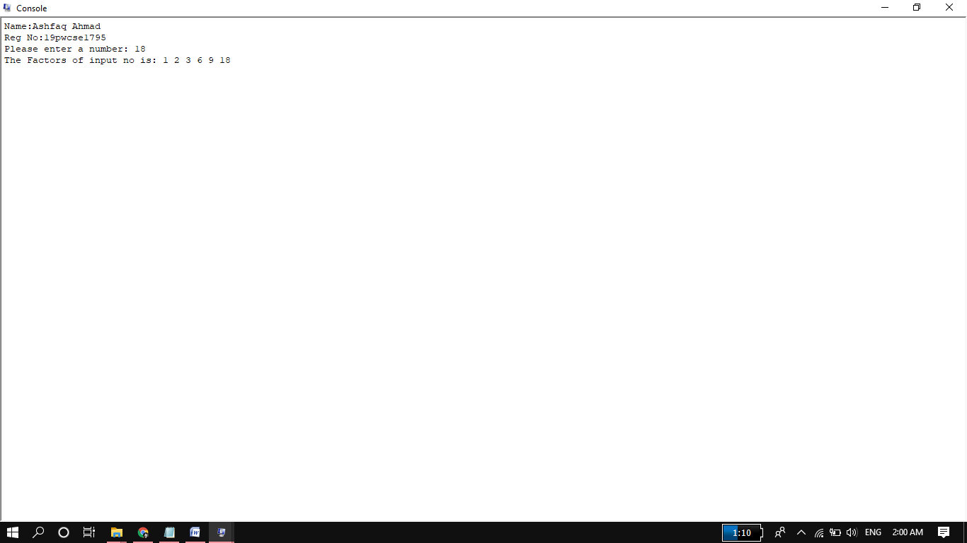

**Task 04:**

Write a MIPS program that prints all prime numbers between two input numbers.

**Source:**

.data

str: .asciiz "Name: Ashfaq Ahmad\n Reg No: 19pwcse1795\n"

str1: .asciiz "please! Enter first No:"

str2: .asciiz "Please! Enter 2nd No:"

str3: .asciiz "All prime Numbers between first and 2nd input excluding these two inputs: "

str4: .asciiz " "

.text

main:

li $v0,4 #name reg no

la $a0,str

syscall

li $v0,4 #first input string

la $a0,str1

syscall

li $v0,5 #first input

syscall

move $t0,$v0

li $v0,4 #2nd input string

la $a0,str2

syscall

li $v0,5 #first input

syscall

move $t1,$v0

addi $t0,$t0,1 #increment lower bond by 1.

li $v0,4 #output string

la $a0,str3

syscall

li $s4,1 #for comperison of counter s3.

li $s5,0 # for checking reminder.

exit6: #this loop continue until t0 reached t1.

bgt $t1,$t0 greater

j exit1

greater:

li $s0,1 #deviser start from 1

li $s3,0 #counting variable

exit4: #this loop will divide a number t0 on s0 from 1 to up to t0 and will count the 0 reminder. It also increment s0 up to t0.

bgt $t0,$s0 greater1 #if condition true then go and perform division

j exit2 #if not then jump out from division.

greater1:

div $t0,$s0

mfhi $s1 #move reminder to s1 for comparison.

beq $s1,$s5 equal #if reminder equal to 0 then increment count and then deviser s0.

j exit3 #else increment deviser only.

equal:

addi $s3,$s3,1

exit3:

addi $s0,$s0,1

j exit4

exit2:

beq $s3,$s4 prime

j exit5 #if this condition not true its mean its not a prime so no need to display and jump to exit5.

prime:

li $v0,1 #display prime no.

move $a0,$t0

syscall

li $v0,4 #display space between prime numbers.

la $a0,str4

syscall

exit5:

addi $t0,$t0,1 #increment t0

j exit6

exit1:

li $v0,10

syscall

**Output:**

